.
In collaboration with Abhishek Anand, Head of Revenue, ATLIQ
Domain : Hospitality
Function : Revenue
Problem statement: Provide insights to the Revenue Manager & Head of Revenue at Atliq Hospitality
About the client : Atliq Hospitality owns multiple five-star hotels across India. They have been in the hospitality industry for the past 20 years. Due to strategic moves from other competitors and ineffective decision-making in management, Atliq Grands are losing its market share and revenue in the luxury/business hotels category. As a strategic move, the managing director of Atliq Grands wanted to incorporate "Business and Data Intelligence" to regain their market share and revenue. However, they do not have an in-house data analytics team to provide then with these insights
Their revenue management team had decided to hire a 3rd party service provider to provide them with insights from their historical data
Objective : Provide with sample data and a mock-up dashboard to work on the following task
1. Create the metrics according to the metric list
2. Create a dashboard according to the mock-up provided by stakeholders.
3. Create relevant insights that are not provided in the metric list/mock-up dashboard for a Revenue
Data and Metrics utilized
1. Property Data : Contains Unique property_id, property_name, category, city categorized each with unique entries and available data
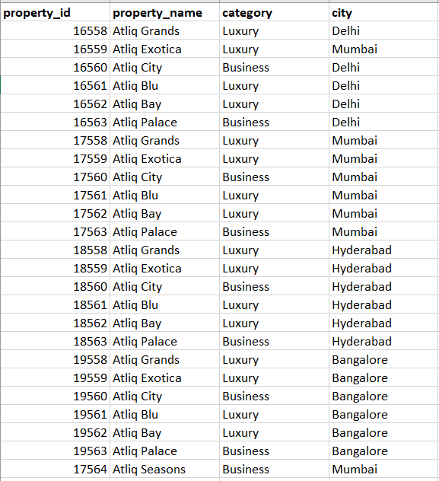
2. Room type Data : 4 different types of room_class available across Atliq Hospitality with unique room_id
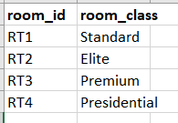
3. Room Booking Data : Detailed data about room booking history containing booking_id, property_id, booking_date, check_in_date, checkout_out, no_of_guests, room_category, booking_platform, ratings_given, booking_status, revenue_generated, revenue_realised
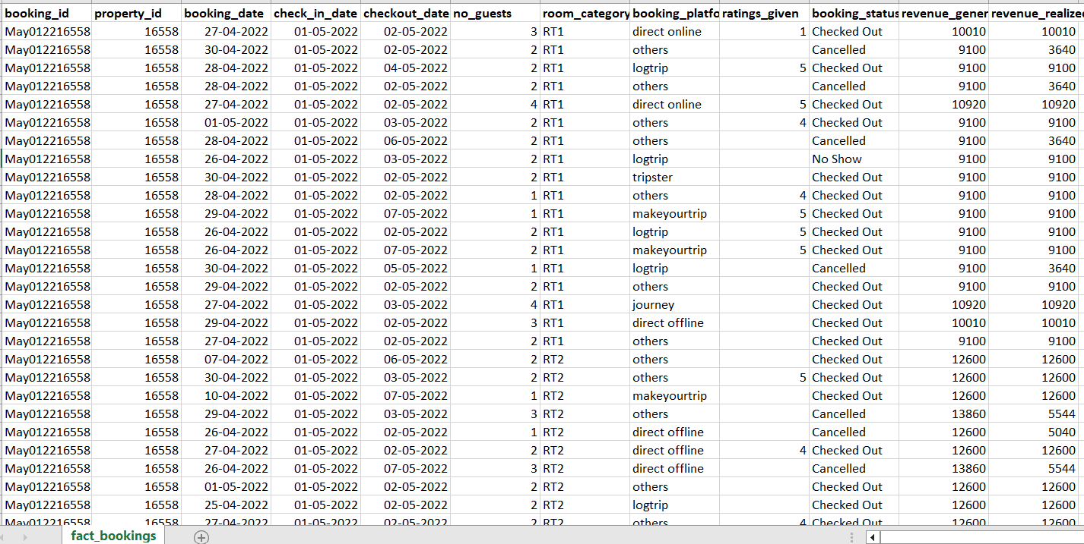
4. Dates and day Data : A distinguished classification of day types in a week as per hospitality industry data involved are date, mmm yy, week no, day_type
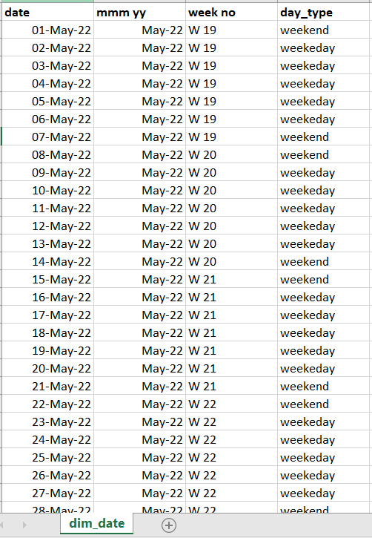
5. Metric list : Metrics used to determine KPI’s in hospitality to measure trends and occurrences
Occupancy %, Avg Rating, Avg Daily Rate (ADR), Realization %, RevPAR, Daily Booked Room Nights (DBRN), Daily Sellable Room Nights (DSRN), Daily Utilized Room Nights (DURN), Revenue WoW Change %, ADR WoW Change %, RevPar WoW Change %, Realisation Wow Change %, DSRN WoW change %
